**Electronics**

EnRoute 2.0 uses a total of three (3) mbeds communicating over RS232 to read from sensors and control various actuators. The connections for each mbed are as follows:

HVAC mbed:

-Two (2) on-off blowers

-One (1) PWM-controlled blowers

-Two (2) servo valves

-One (1) flow meter

-Two (2) temperature sensors

-One (1) Ethernet port

-One (1) communication switch (IP v. Serial)

-One (1) on-off heater via dimmer switch

-Two (2) sets of RS232 communication lines from Zone1 and Zone2

-Five (5) status LEDs

Zone1 mbed:

-Two (2) servo valves

-Two (2) temperature sensors

-Two (2) flow meters

-One (1) set of RS232 communication lines

-One (1) 6V input signal for power and servos

Zone2 mbed:

-Two (2) servo valves

-Two (2) temperature sensors

-Two (2) flow meters

-One (1) set of RS232 communication lines

-One (1) 6V input signal for power and servos

To handle all the connections between the various mbeds there is a ‘Wiring Router’ located on the back of Room 1, as shown below in Figure 1. The energy router has a cover that labels what connections are supposed to be made and where, but the flow is given here as well.

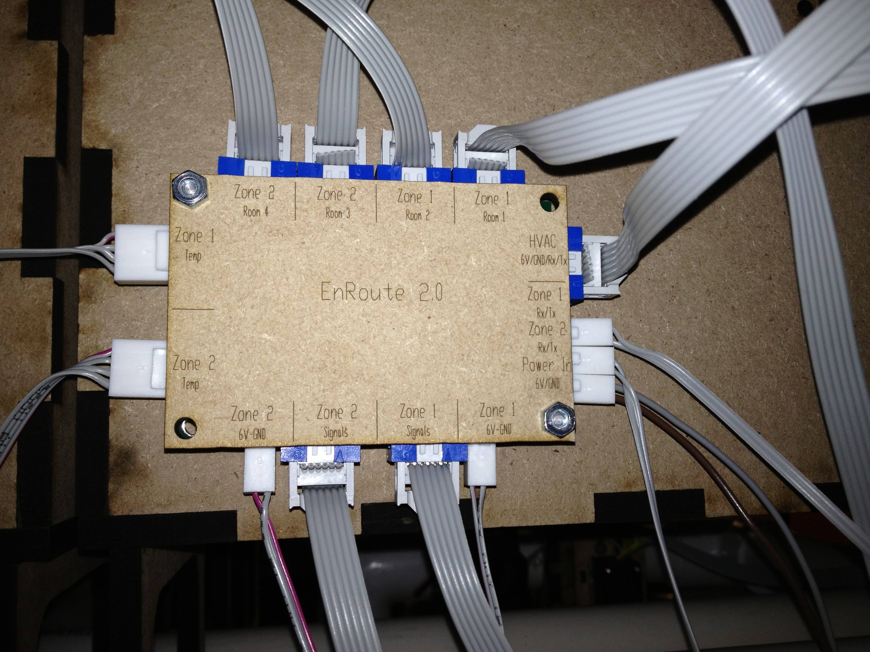

Figure 1: Wiring Router

On the bottom of the right hand side there is an input for a 6 V supply, which is used to power Zone1 and Zone2 mbeds as well as provide power for all servo-motors. Directly above that are the input lines for Rx/Tx lines coming from Zone1 and Zone2. The remaining 6-pin connector on the right hand side is the output to the HVAC mbed, which includes two lines for 6 V, and four lines for the Rx/Tx lines from the other zones.

The top side includes four (4) 6-pin connectors, one for each room, which are for the servo valves (3 pins each) and flow meters (3 pins each).

The left side has two (2) 4-pin connections that go to rooms 2 and 4. These pins provide connections for temperature sensors (3.3V, GND, signal, vacant).

The bottom side has two (2) 2-pin connections that provide the 6 V signal to zones 1 and 2. Additionally there are two (2) 6-pin connectors that provide the two temperature sensor signals, two servo valve signals, and two flow meter signals to the zones for each mbed.